**Spike:** Spike_3

**Title:** Spike_Emergent Group Behaviour

**Author:** Le Bao Duy Nguyen 102449993

**Goals / deliverables:**

* Short report titled “Spike_Emergent Group Behaviour”
* Modify agent to include cohesion, separation, alignment with alterable value adjustment
* Include basic wandering and weighted sum of all steering behaviours

**Technologies, Tools, and Resources used:**

* Visual Studio Code
* Python 3.0+

**Tasks undertaken:**

* Download and install Visual Studio Code
* Download and install Python 3.0 & above
* Download and install Python extension within Visual Studio Code
* Read the codes and guidelines. Researching Canvas materials as well as Google, YouTube, etc.

Bot functions for Cohesion, Separation, Alignment. TagNeighbours to check if the agent has any close by agent to steer with.

def tagNeighbours(self,bots,radius) :

self.neighbours.clear();

for bot in bots :

if bot != self :

bot.tagged = False

to = self.pos - bot.pos

gap = radius + bot.bRadius

if to.length_sq() < gap**2 :

bot.tagged = True

self.neighbours.append(bot)

def Seperation(self,group):

SteeringForce = Vector2D()

for bot in group:

if bot != self and bot.tagged:

ToBot = self.pos - bot.pos

SteeringForce += ToBot.normalise() / ToBot.length()

return SteeringForce

def Alignment(self,group):

AvgHeading = Vector2D()

AvgCount = 0

for bot in group:

if bot != self and bot.tagged:

AvgHeading += bot.heading

AvgCount +=1

if AvgCount > 0:

AvgHeading /= float(AvgCount)

AvgHeading -= self.heading

return AvgHeading

def Cohesion(self,group):

CentreMass = Vector2D()

SteeringForce = Vector2D()

AvgCount = 0

for bot in group:

if bot != self and bot.tagged :

CentreMass += bot.pos

AvgCount += 1

if AvgCount > 0 :

CentreMass /= float(AvgCount)

SteeringForce = self.seek(CentreMass)

return SteeringForce

Weighted sum that adds 3 steering behaviours together.

def sumBehaviours(self,delta):

self.tagNeighbours(self.world.agents,self.neighbourR)

if len(self.neighbours) == 0 :

return self.wander(delta)

cohesion = self.Cohesion(self.neighbours) * self.CohesionWeight

alignment = self.Alignment(self.neighbours) * self.AlignmentWeight

seperation = self.Seperation(self.neighbours) * self.SeperationWeight

return cohesion + alignment + seperation

Default value

self.cohesion = 0.0

self.seperation = 0.0

self.alignment = 0.0

self.radius = 10.0

Control value of each steering behaviour

elif symbol == KEY.A:

for agent in world.agents:

agent.SeperationWeight += 0.5;

elif symbol == KEY.S:

for agent in world.agents:

agent.SeperationWeight -= 0.5;

elif symbol == KEY.T:

for agent in world.agents:

agent.CohesionWeight += 0.5;

elif symbol == KEY.Y:

for agent in world.agents:

agent.CohesionWeight -= 0.5;

elif symbol == KEY.D:

for agent in world.agents:

agent.AlignmentWeight += 0.5;

elif symbol == KEY.F:

for agent in world.agents:

agent.AlignmentWeight -= 0.5;

elif symbol == KEY.N:

world.separation = 0

world. alignment = 0

world.cohesion = 0

world.radius = 10

Parameters of each value are shown on screen

if self.showinfo:

infotext = ', '.join(set(agent.mode for agent in self.agents))

egi.red_pen()

egi.text_at_pos(0, 0, infotext)

infotext = ': '.join(('Cohesion', str(self.cohesion)))

egi.red_pen()

egi.text_at_pos(0, 487, infotext)

infotext = ': '.join(('Separation', str(self.seperation)))

egi.red_pen()

egi.text_at_pos(0, 448 , infotext)

infotext = ': '.join(('Alignment', str(self.alignment)))

egi.red_pen()

egi.text_at_pos(0, 461, infotext)

infotext = ': '.join(('Radius', str(self.radius)))

egi.red_pen()

egi.text_at_pos(0, 480, infotext)

**Issue:**

Parameters cannot be displayed on screen. Egi.[ ]_pen is not working. This can be due to Mac issue since it has occurred in previous labs before.

**Output:**

Normal screen

Alignment enabled

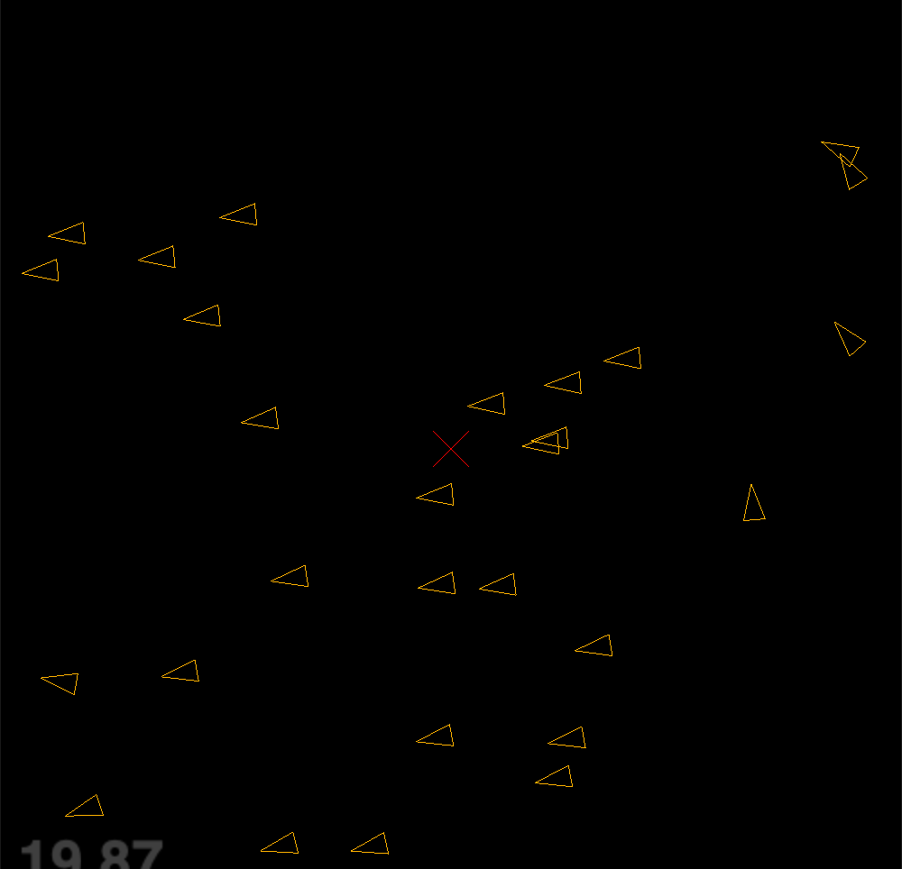

Separation enabled

Cohesion enabled

